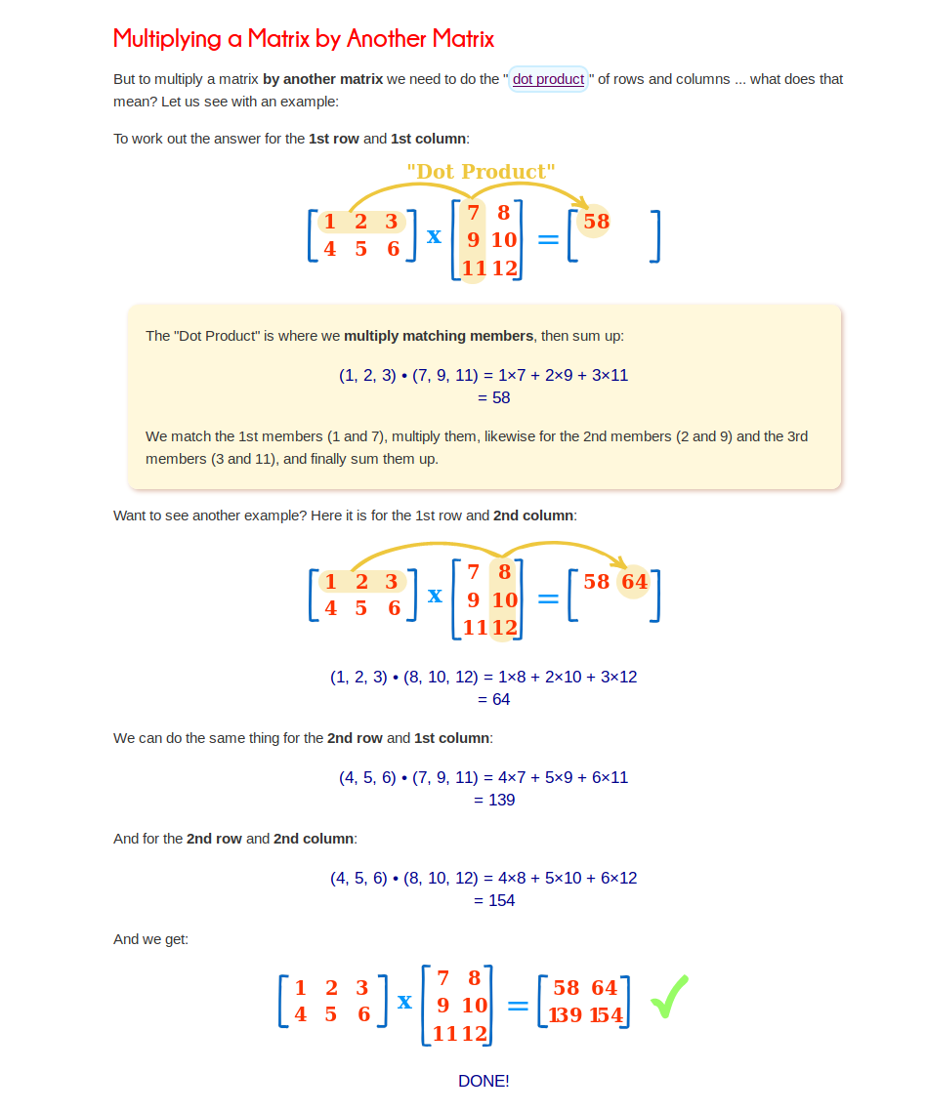
2 x 3 @ 3 x 2 – if the red match then you can multiply

